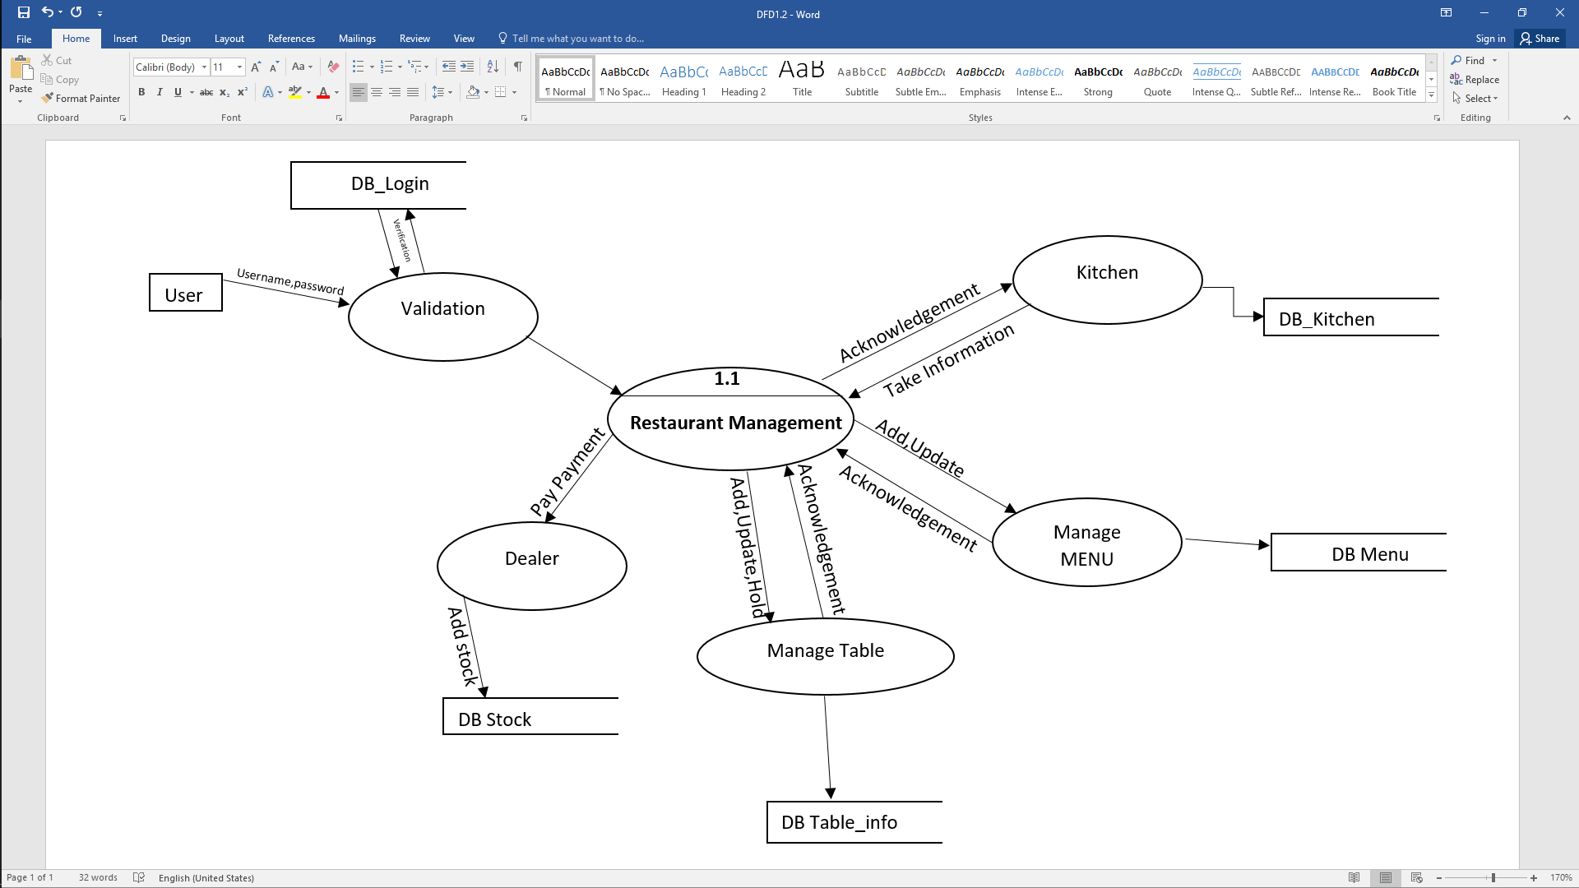

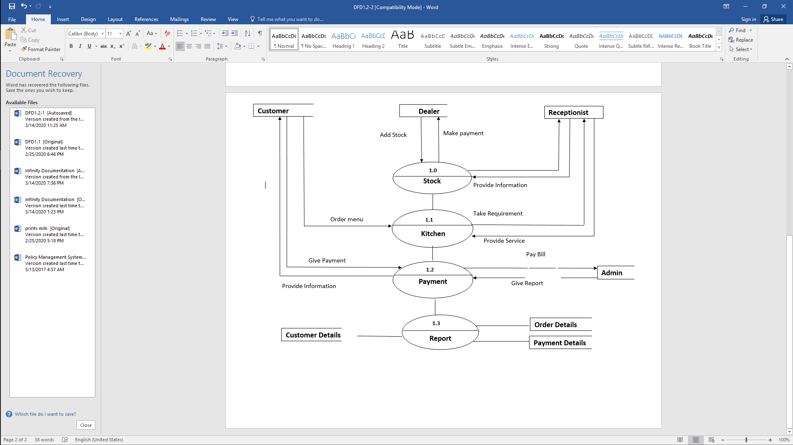

Make payment

Add Stock

**Dealer**

**Customer**

**Receptionist**

**1.0**

Provide Information

Give Report

**Admin**

**Payment Details**

**Order Details**

**Customer Details**

**1.3**

Give Payment

**1.2**

Order menu

Pay Bill

Provide Information

Take Requirement

**1.1**

Provide Service